Project Plan
CSC-4710-02 | 1/28/2026
Professionally Cursed
Hudson Wesel, Samira Rochdi, Austin Persek, Mark Metcalf


Table of Contents
Project Name 3
Team Members 3
Sponsor/Customer 3
Work Breakdown 4
Complete Description of Problem (defined by customer) 4
Project Goals 5
Project Scope 5
Hardware and Software Requirements 6
Schedule 6
Delivery Plan 7
Communication and Reporting 7
Risks & Constraints 7
!C01 - Project Constraints 7
!R01 - Risks 8

Table of Tables
Table 1: Our planned development cycle for this project 6
Table 2: Constraints we face throughout the life cycle of this project 8
Table 3: Risks we face throughout the life cycle of this project 8

Project Name
- Panther Cloud Air - Airline Simulation

Team Members
Hudson Wesel - Project Leader
- Experienced with Python, C++, and front-end stack (HTML/SCSS/JavaScript). Responsible for performing and validating all project calculations, developing the calculation simulation program, and backend design (REST API / RDBMS design). In addition, any infrastructure needs (Nginx, docker-containers, etc.)
Samira Rochdi - Principal Developer
- Experienced with Python, C++, MySQL, and HTML. Responsible for performing and validating all project calculations, translating mathematical models into system logic, and supporting implementation of the core simulation components.
Austin Persek - Quality Assurance
- Experienced with Python, HTML, CSS, and JavaScript. Responsible for double checking outputs, documents, and all deliverables. Leading development of Front-End Web Application.
Mark Metcalf - Documentation Specialist
- Experienced with C++, Python, MySQL, HTML, and CSS. Plans to mostly prepare deliverables and presentations as well as assisting with the front-end web application and back-end SQL database and Python code.

Sponsor/Customer
A group of wealthy investors interested in starting an airline titled Panther Cloud Air.

Work Breakdown
Hudson Wesel
- Hudson set up the repository, created .csv files with the flight cost between each airport and distance between each airport, as well as setting up JSON files to help send data between all our Python files, contributing over 8000 lines of code. He also helped the group set up SSH keys for the repository and demonstrated how to use VS Code to push changes with git.
Samira Rochdi
- Samira did most of the calculations needed to set up the back end and assisted Hudson with coding the back end. She also created .md files to show the thought process with the calculations for transparency with our customer. She also helped with drafting the Project Plan alongside Austin and Mark.
Austin Persek
- Austin set up an initialized front end by setting up an HTML page as well as the layout of the webpage alongside Hudson, as well as assisting Hudson and Samira with calculations for the back end and drafting the Project Plan alongside Samira and Mark.
Mark Metcalf
- Mark recorded all current minutes, set up drafts of documents, set up and refurbished our Trello page, created the presentation for Walkthrough #1 and most of the Project Plan. He also helped calculate how many people wanted to fly between two airports at any given time.

Complete Description of Problem (defined by customer)
The goal of this project is to design and implement an airline simulation system for Panther Cloud Air that evaluates operational feasibility and financial performance. The simulation aims to maximize revenue by efficiently scheduling flights, allocating aircraft, and managing passenger demand while accounting for real-world constraints such as weather conditions, delays, and maintenance costs. The system will provide meaningful analytics through a web-based interface backed by a robust database and simulation engine.

Project Goals
- Our goal for this project is to create a simulation for Panther Cloud Air that generates as much revenue as possible for our customers. We plan to achieve this by creating a front-end HTML webpage connecting to a PostgreSQL server. Our Python back end will take data from our JSON files to create accurate results.
- Our simulation will support a wide variety of events such as delays, bad weather, and strong tailwinds, ensuring our simulation covers all bases and provides the most accurate simulation for the airline.

Project Scope
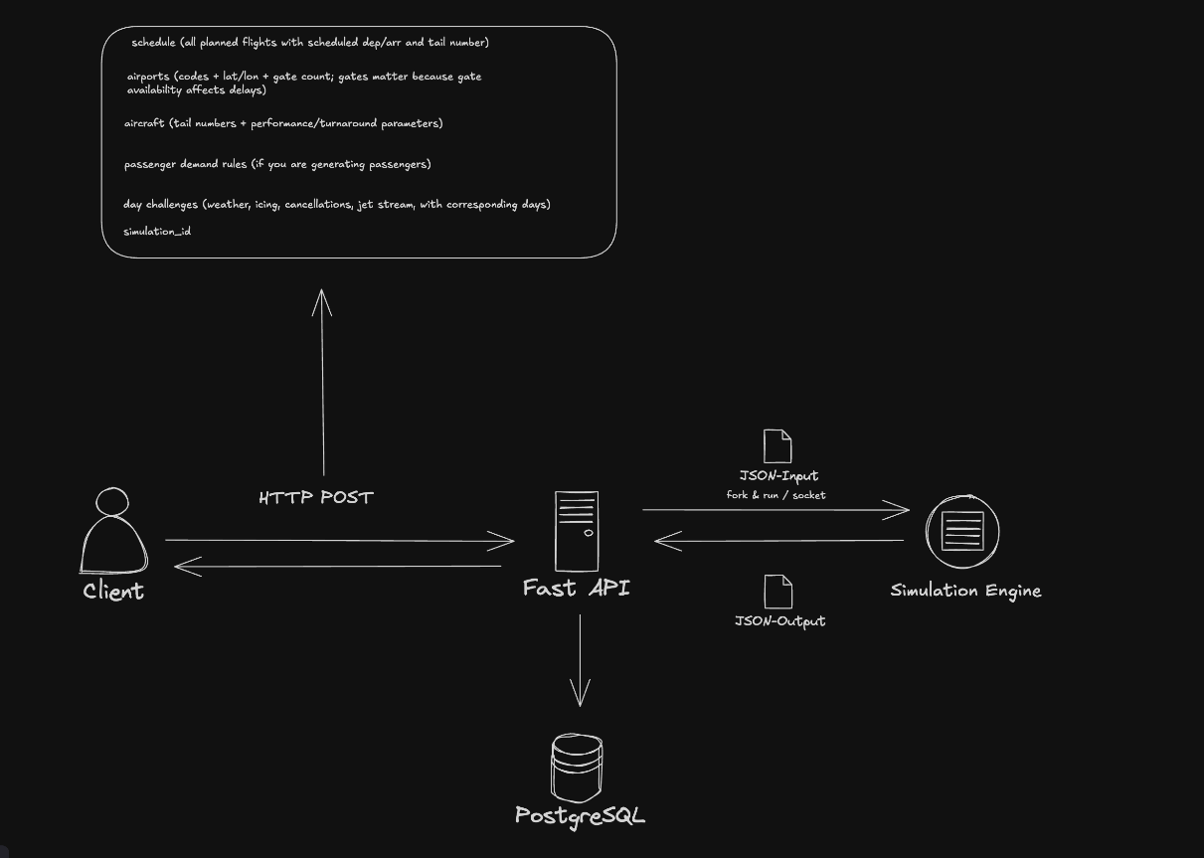
- The project consists of a web-based front-end, a Python-based simulation engine, and a PostgreSQL database.
- Our front-end will allow our customers to easily interact with the program and back end, allowing them to see origin/destination airports as well as arrival and departure times in corresponding time zones for each plane in our fleet, ensuring simple tracking.
- Our Python back end will be performing all the calculations needed to ensure a successful simulation. Tasks vary from placing passengers on available aircraft, changing conditions to simulate several different events in our project goals, managing plane availability and refueling/repairs, and calculating conversions between multiple units of measurement. JSON files will store many of our constants, which can be imported into our Python back end and be returned to our API.
- The PostgreSQL server will store updated data from our simulation, such as profit/loss margins and passengers on a given plane to use for financial analysis.

Hardware and Software Requirements
- Hardware
- 32 GB RAM
- Intel Core Ultra 7 CPU
- 120 GB of free disk space
- 14’’ Monitor
- Software
- Microsoft 11 Enterprise OS
- PostgreSQL
- Python 3.14 Interpreter
- python3.14 -m venv .venv
source .venv/bin/activate
python -m pip install -r ./src/requirements.txt

Schedule
Week 6 | All HTML webpages should be created and linked to each other in the repository.
Week 7 | All calculations for our back end will be complete.
Week 8 | GROUP SPLIT – Will return next week.
Week 9 | Tables on the front end will be successfully rendered and present data.
Week 10 | HTML webpages will be finalized.
Week 11 | Integrate front end, back end, and database.
Week 12 | Test simulation accuracy and handle edge cases.
Week 13 | Finalize documentation and optimize system performance.
Week 14 | Fix any issues or bugs with our prototype.
Week 15 | Fix any issues or bugs with our prototype.
Week 16 | Demonstrate the final build of the project to the client.
Table 1: Our planned development cycle for this project

Delivery Plan
- February
- Deliver the Project Plan to the client on 2/9/26
- March
- Deliver the Requirements Document to the client on 3/6/26
- Deliver the User Manual to the client on 3/20/26
- April
- Deliver the Specification Document to the client on 4/1/26
- Deliver the Final Design Document to the client on 4/17/26
- Demonstration of the simulation application to the client on 4/25/26

Communication and Reporting
- SMS - Our group utilizes a variety of communication tools to complete this project effectively. We are utilizing I Message for quick communication and updates daily.
- TRELLO - Trello is our group's primary task management software. We have created three Trello boards for the front-end, back end, and math.
- DISCORD – Our group is utilizing discord to collaborate virtually. Discord’s screen sharing features make collaboration on programming and problem solving extremely efficient.
- GITHUB – GitHub is our version control system. GitHub enables collaborative development, code management, and change tracking throughout the development of this project.

Risks & Constraints

!C01 - Project Constraints
Identifier | Constraint Name | Constraint Description
!C01.01 | Compatible with Hudson’s server | All production code needs to be compatible with Hudson’s home server.
!C01.02 | Researching airports and costs | We have limited knowledge of airports and how they operate. Calculations and research will be required to produce quality simulations.
!C01.03 | Compatible with client specs | The scope of the project must not exceed the client’s hardware specs.
!C01.04 | Due by the end of April | The client requests the simulations to be completed around the end of April, which is across the span of 16 weeks (about 3 and a half months).
!C01.05 | Limited to top 30 US airports and France | Airports that Panther Cloud Air can operate in are limited to France and the top 30 busiest airports in the US.
!C01.06 | Conflicting events for each team member | Team members have different responsibilities they need to attend outside of this project, whether it’s other courses or job interviews. We know Mark will attend 2 conferences in March, meaning he will miss around 5 group meetings.
Table 2: Constraints we face throughout the life cycle of this project

!R01 - Risks
Identifier | Risk Name | Risk Description
!R01.01 | Data Breach | We suffer from data breaches during development, losing data, and customer trust.
!R01.02 | Snowstorms and ice storms | Snowstorms or ice storms take down power and halt any progress we can make on the project.
!R01.03 | SQL databases not supported | Client systems are unable to run SQL databases of any kind, rendering our application unusable.
!R01.04 | Airport internet malfunctions | Airport internet isn’t available or gets overloaded, hindering or disabling our web application.
!R01.05 | GitHub goes down during development | GitHub fails and prevents our git requests from being pushed, halting all work.
!R01.06 | Can’t meet in person due to unforeseen circumstance | We can’t meet in person, whether through car trouble or if someone gets sick. This will briefly reduce our productivity.
!R01.07 | Hardware failure or DDOS attack | Server stability and structure need to be sound. If a server goes down for any reason, data cannot be recorded and risks being wiped.
Table 3: Risks we face throughout the life cycle of this project

